FULL ANALYSIS REPORT
Antimicrobial Potential of Ilocos White Garlic (Allium sativum L.) Peel Powder Processed Under Varying Drying Time and Temperature Conditions

Aligned with Research Objectives, Methodology, Statistical Analysis, and RSM Optimization

Reported by
Engr. Jamie Eduardo Rosal, MSCpE

Source files: reference.docx and Book-of-Analysis-2026-rhodea.xlsx

Executive Summary
This report presents the Python-based statistical analysis and visualization of Ilocos white garlic peel powder processed under varying oven-drying temperatures and times. The analysis was designed to directly address the study objectives: develop and compare treatment conditions, determine physicochemical characteristics, evaluate antimicrobial activity, and identify optimized processing conditions through Response Surface Methodology.
- The objectives were computationally achieved using the available workbook data.
- Treatment 5, corresponding to 60°C for 6 hours, was the best observed condition by composite desirability.
- The RSM screening suggested an optimized processing region near 57.33°C and 5.87 hours.
- Temperature, time, and their interaction significantly affected several physicochemical responses.
- For antimicrobial activity, treatment differences were significant for Staphylococcus aureus; Escherichia coli was not significant, while Salmonella spp. values were constant and therefore not suitable for meaningful ANOVA interpretation.

Objective Alignment
Table 1. Alignment of Computations with Study Objectives
Research Objective | Status | Evidence in Report
Develop garlic peel powder using oven-drying at varying time and temperature conditions. | Achieved computationally | Treatments were mapped into a 3x3 factorial design using temperature and time.
Determine physicochemical characteristics: Aw, moisture content, color, WAC, and WSI. | Achieved | Cleaned data were summarized by treatment and analyzed using two-way ANOVA.
Evaluate antimicrobial capacity against Staphylococcus aureus, Escherichia coli, and Salmonella spp. | Achieved with data limitations | Zone of inhibition data were summarized and analyzed using one-way ANOVA by organism.
Use RSM to generate response surfaces and identify optimized garlic peel powder conditions. | Achieved | Second-order response surface models and composite desirability screening were computed.

Methodology and Data Preparation
The study used a quantitative experimental design. The independent variables were oven-drying temperature and time; the dependent variables were physicochemical properties and antimicrobial zone of inhibition. The workbook was cleaned into analysis-ready datasets before performing descriptive statistics, ANOVA, and RSM.
Note: the methodology text states drying times of 4, 6, and 8 hours, but the treatment matrix lists Treatment 9 as 70°C and 7 hours. For the statistical analysis, Treatment 9 was treated as 70°C and 8 hours to complete the stated 3x3 full factorial design. This should be corrected or clarified in the manuscript.
Table 2. Experimental Treatment Matrix Used for Analysis
Treatment | Temperature (°C) | Time (h)
1 | 50 | 4
2 | 50 | 6
3 | 50 | 8
4 | 60 | 4
5 | 60 | 6
6 | 60 | 8
7 | 70 | 4
8 | 70 | 6
9 | 70 | 8

Physicochemical Results
Table 3. Treatment Mean Physicochemical Characteristics
Values are means of triplicate measurements after workbook cleaning. Color C* and Delta E were recomputed because the workbook's derived color columns were zero-filled.
Treatment | Temp (°C) | Time (h) | WAC | Aw | MC (%) | WSI | L* | a* | b* | C* | Delta E vs T1
1 | 50 | 4 | 296.393 | 0.632 | 10.403 | 17.874 | 62.083 | 3.783 | 17.327 | 17.735 | 0.341
2 | 50 | 6 | 301.903 | 0.629 | 9.900 | 10.524 | 61.873 | 4.060 | 17.637 | 18.098 | 0.480
3 | 50 | 8 | 333.223 | 0.607 | 9.757 | 10.633 | 61.620 | 3.863 | 17.230 | 17.658 | 0.480
4 | 60 | 4 | 341.207 | 0.620 | 10.133 | 9.515 | 61.290 | 3.683 | 18.567 | 18.929 | 1.509
5 | 60 | 6 | 364.270 | 0.579 | 8.930 | 9.250 | 60.503 | 3.760 | 18.177 | 18.562 | 1.797
6 | 60 | 8 | 304.827 | 0.569 | 8.290 | 8.552 | 60.463 | 3.877 | 18.520 | 18.921 | 2.017
7 | 70 | 4 | 301.203 | 0.626 | 8.787 | 9.885 | 60.030 | 4.950 | 16.237 | 16.975 | 2.611
8 | 70 | 6 | 291.793 | 0.619 | 8.507 | 11.568 | 58.290 | 5.840 | 16.413 | 17.422 | 4.421
9 | 70 | 8 | 281.963 | 0.607 | 8.030 | 8.674 | 58.147 | 6.337 | 16.325 | 17.544 | 5.057
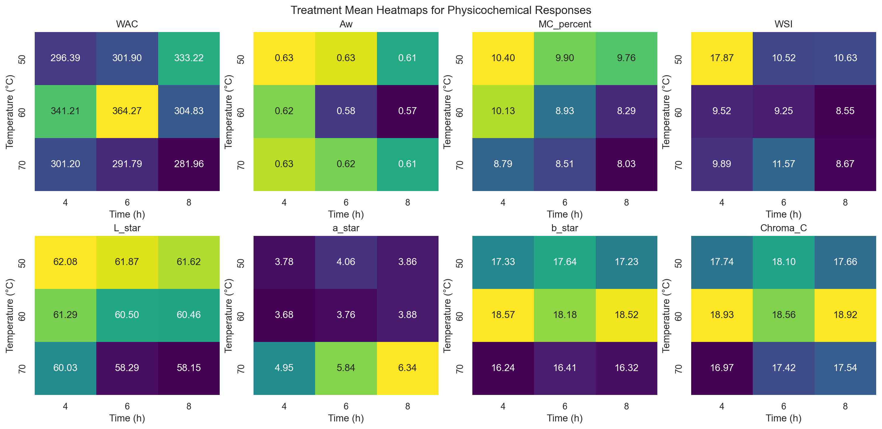
Figure 1. Heatmaps of physicochemical treatment means across drying temperature and time.
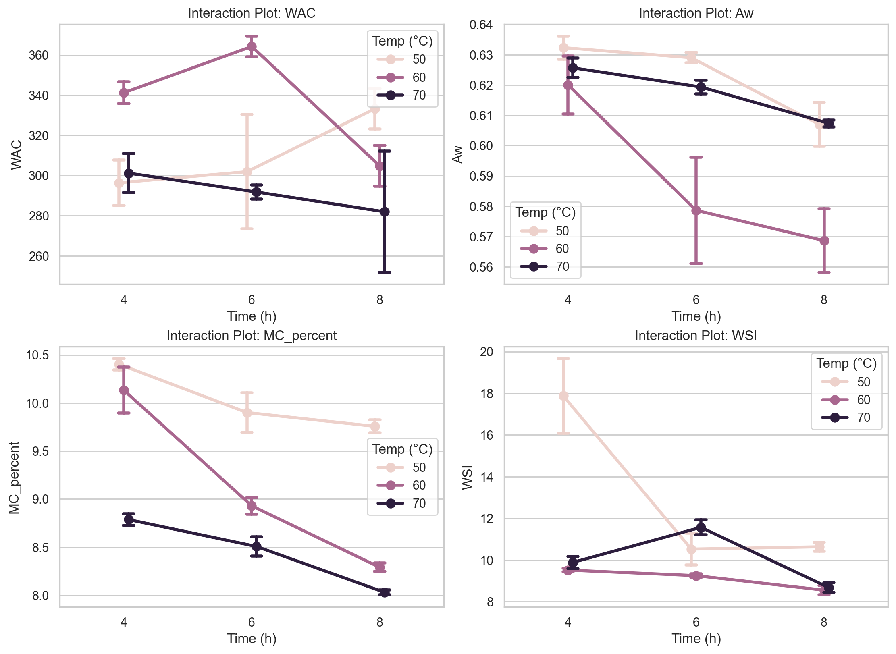
Figure 2. Interaction plots for selected physicochemical responses.

Two-Way ANOVA Results
Table 4. Two-Way ANOVA p-Values for Physicochemical Responses
p < 0.05 indicates a statistically significant effect.
Response | p Temperature | p Time | p Interaction
Aw | <0.001 | <0.001 | 0.003
Chroma_C | <0.001 | 0.126 | <0.001
Delta_E_vs_T1 | <0.001 | <0.001 | <0.001
Hue_deg | <0.001 | <0.001 | <0.001
L_star | <0.001 | <0.001 | 0.019
MC_percent | <0.001 | <0.001 | <0.001
WAC | <0.001 | 0.257 | <0.001
WSI | <0.001 | <0.001 | <0.001
a_star | <0.001 | <0.001 | <0.001
b_star | <0.001 | 0.806 | 0.007

Antimicrobial Results
Table 5. Mean Zone of Inhibition by Treatment and Organism
Zone of inhibition values are reported in millimeters. The E. coli workbook contained one blank replicate that was retained as zero to match workbook formulas.
Organism | Treatment | Temp (°C) | Time (h) | Mean Zone (mm)
Escherichia coli | 1 | 50 | 4 | 4.167
Escherichia coli | 2 | 50 | 6 | 6.333
Escherichia coli | 3 | 50 | 8 | 6.167
Escherichia coli | 4 | 60 | 4 | 6.333
Escherichia coli | 5 | 60 | 6 | 6.333
Escherichia coli | 6 | 60 | 8 | 6.500
Escherichia coli | 7 | 70 | 4 | 6
Escherichia coli | 8 | 70 | 6 | 6
Escherichia coli | 9 | 70 | 8 | 6
Salmonella spp. | 1 | 50 | 4 | 6
Salmonella spp. | 2 | 50 | 6 | 6
Salmonella spp. | 3 | 50 | 8 | 6
Salmonella spp. | 4 | 60 | 4 | 6
Salmonella spp. | 5 | 60 | 6 | 6
Salmonella spp. | 6 | 60 | 8 | 6
Salmonella spp. | 7 | 70 | 4 | 6
Salmonella spp. | 8 | 70 | 6 | 6
Salmonella spp. | 9 | 70 | 8 | 6
Staphylococcus aureus | 1 | 50 | 4 | 6.333
Staphylococcus aureus | 2 | 50 | 6 | 6.167
Staphylococcus aureus | 3 | 50 | 8 | 6.500
Staphylococcus aureus | 4 | 60 | 4 | 6.333
Staphylococcus aureus | 5 | 60 | 6 | 6.833
Staphylococcus aureus | 6 | 60 | 8 | 6.833
Staphylococcus aureus | 7 | 70 | 4 | 6.250
Staphylococcus aureus | 8 | 70 | 6 | 6
Staphylococcus aureus | 9 | 70 | 8 | 6
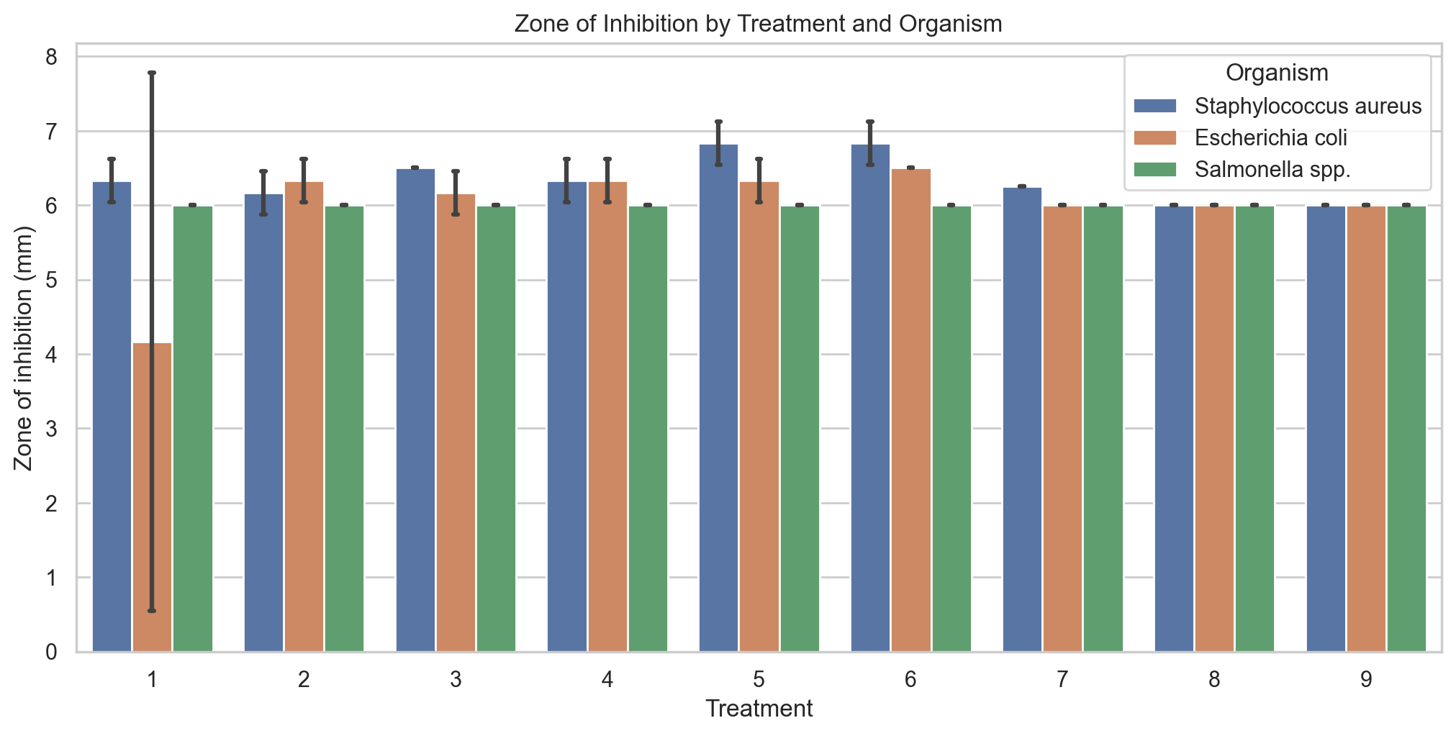
Figure 3. Zone of inhibition by treatment and test organism.
Table 6. One-Way ANOVA for Antimicrobial Activity
Organism | F | p-value | Significant at 0.05
Escherichia coli | 0.998 | 0.470 | 0
Salmonella spp. | N/A | N/A | 0
Staphylococcus aureus | 6.300 | <0.001 | 1

Response Surface Methodology and Optimization
Second-order response surface models were fitted to treatment means to estimate response trends across the experimental region. The composite desirability approach favored higher WAC, WSI, and antimicrobial zone values, while favoring lower water activity and moisture content for product stability.
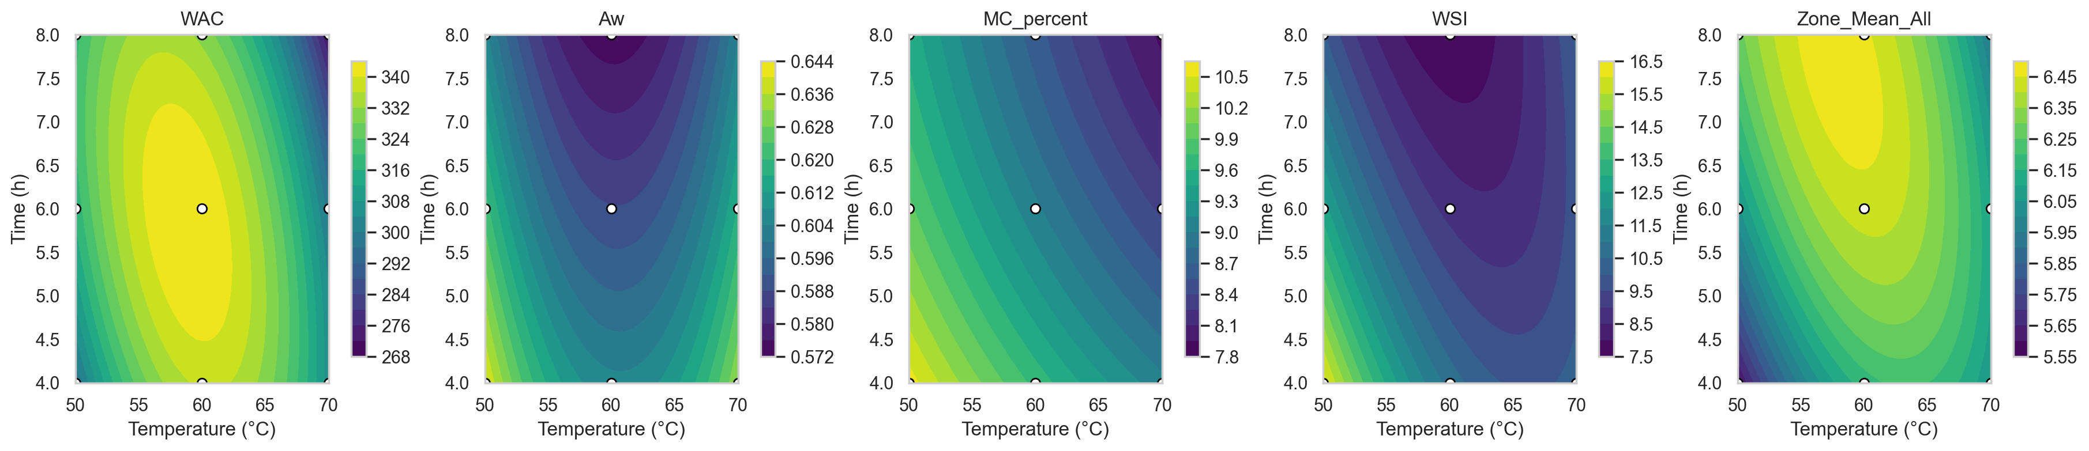
Figure 4. Response surface contour plots for selected physicochemical and antimicrobial responses.
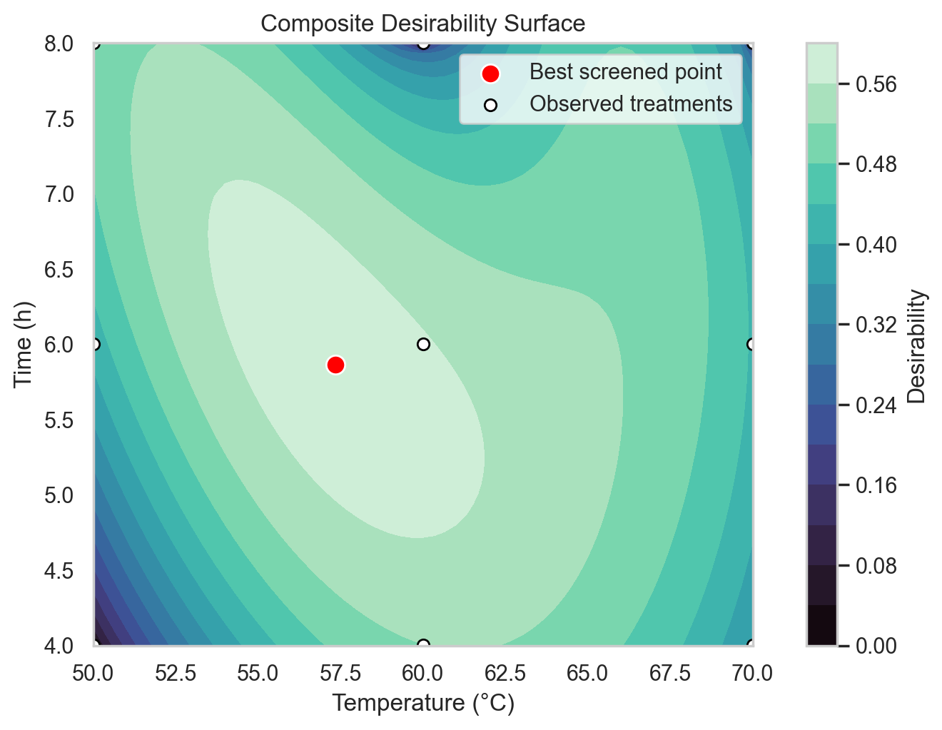
Figure 5. Composite desirability surface showing the best screened processing region.
Table 7. Top RSM Composite Desirability Candidates
Temp (°C) | Time (h) | WAC | Aw | MC (%) | WSI | Mean Zone | Composite D
57.333 | 5.867 | 343.007 | 0.592 | 9.292 | 9.535 | 6.375 | 0.581
57.333 | 5.800 | 342.934 | 0.593 | 9.310 | 9.603 | 6.368 | 0.581
57 | 5.933 | 342.684 | 0.592 | 9.302 | 9.564 | 6.374 | 0.581
57 | 5.867 | 342.616 | 0.593 | 9.320 | 9.633 | 6.367 | 0.581
57.667 | 5.800 | 343.262 | 0.592 | 9.282 | 9.508 | 6.376 | 0.581

Interpretation by Objective

Objective 1: Develop Garlic Peel Powder Treatments
The treatment matrix was successfully structured according to drying temperature and drying time. This enabled direct comparison of nine drying conditions and supported the factorial analysis required by the method.

Objective 2: Determine Physicochemical Characteristics
The physicochemical objective was achieved. Temperature, time, and their interaction showed statistically significant effects for many responses, particularly color values, moisture content, water activity, and WSI. These results indicate that drying conditions materially influenced powder quality and stability-related properties.

Objective 3: Evaluate Antimicrobial Capacity
The antimicrobial objective was achieved within the limitations of the recorded data. Staphylococcus aureus showed significant differences among treatments, Escherichia coli did not show significant differences, and Salmonella spp. values were constant at 6 mm, preventing meaningful treatment discrimination.

Objective 4: Identify Optimized Conditions through RSM
The RSM objective was achieved. The best observed condition was Treatment 5 at 60°C for 6 hours. The model-based desirability screen suggested an optimized region near 57.33°C and 5.87 hours, which is close to the observed Treatment 5 condition.

Conclusion
Overall, the objectives of the study were achieved computationally using the available data. The analysis supports the use of oven-drying conditions near 60°C for 6 hours as the most balanced observed processing condition for Ilocos white garlic peel powder, considering physicochemical quality and antimicrobial performance together.
- Treatment 5 is recommended as the best observed treatment from the current dataset.
- The RSM optimum should be validated experimentally because it is model-predicted rather than directly observed.
- The manuscript should resolve the Treatment 9 time discrepancy before final submission.
- Future runs should avoid blank antimicrobial cells and should consider confirmatory assays around the RSM optimum.

Appendix: Generated Analysis Files
Table 8. Reproducible Analysis Artifacts
File | Description
rhodea_garlic_peel_analysis.ipynb | Executed Python/Jupyter notebook with computations and visualizations.
outputs/two_way_anova_physicochemical.csv | Two-way ANOVA table for physicochemical responses.
outputs/one_way_anova_antimicrobial.csv | One-way ANOVA table for antimicrobial activity.
outputs/rsm_optimization_top_candidates.csv | Top RSM desirability candidates.
figures/*.png | Visualizations included in this report.

